Ideation Phase
Empathize & Discover

Date | 28 November 2025
Team ID
Project Name | Book Store
Maximum Marks | 4 Marks

Empathy Map Canvas:
Book buyers (students, working professionals & book lovers) are often frustrated due to limited availability, delayed deliveries, price variations and the inability to easily find their preferred books online. They desire a smooth, fast, and affordable digital book shopping experience.

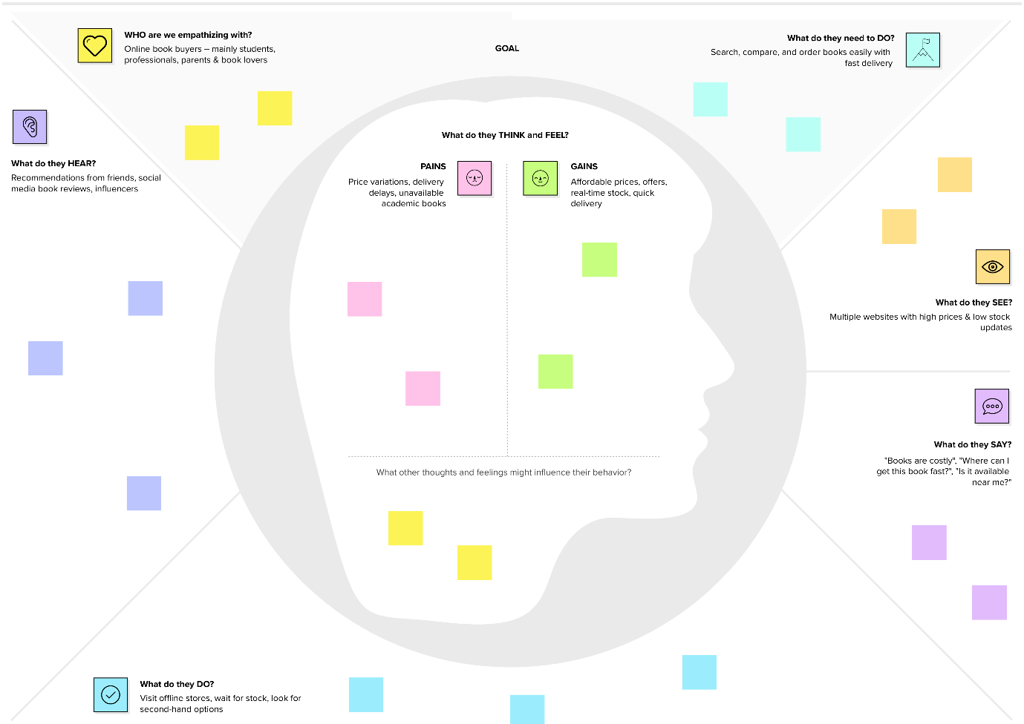

Reference: https://www.mural.co/templates/empathy-map-canvas

